# Contribution of Offshore Wind to the Grid Mix and Air Quality Implications: U.S. National Approach

**Morgan S. Browning a,*, Carol S. Lenox b**

a Oak Ridge Institute for Science and Education (ORISE) Research Fellow, U.S. Environmental Protection Agency, Office of Research and Development, 109 TW Alexander Dr., NC 27709, United States

b U.S. Environmental Protection Agency, Office of Research and Development, 109 TW Alexander Dr., NC 27709, United States

* Corresponding author. *Email address:* [browning.morgan@epa.gov](mailto:browning.morgan@epa.gov) (M.S. Browning)

## Abstract

Offshore wind (OSW) is an established technology in Europe, but it has not yet gained market share in the United States (U.S.). There is, however, increasing interest in and action supporting OSW development from many coastal states, predominantly along the Atlantic coast. As OSW grows in the U.S., as seems likely, it will displace existing generation assets, and depending on which assets those are, the resulting emissions from the electric power sector. This research explores combinations of two energy sector drivers, OSW costs and carbon dioxide (CO2) mitigation stringency, to measure the changes in the energy mix and quantify OSW’s impact on the resulting emissions.

For this analysis, an energy system modeling approach is used to generate and explore potential energy futures. The approach uses The Integrated MARKAL-EFOM System (TIMES) energy system model and a nine-region database representation of the U.S. energy system called the EPAUS9rT, applying a nested parametric sensitivity analysis to represent potential futures. This sensitivity analysis allows us to explore the benefits of OSW as an energy source within the U.S. as it relates to air quality and GHG emissions reductions. The combinations of CO2 mitigation stringencies and OSW cost curves create vastly different energy futures with comparably different emissions profiles. We found that OSW was introduced at higher rates due to costs more than CO2 mitigation stringency, though both had a measurable positive impact. Buildout varied more by CO2 mitigation stringency at higher prices and less at lower prices. Additionally, we found that while CO2 mitigation led to a statistically significant reduction in all five emissions investigated, OSW capacity only led to a statistically significant reduction in CO2 and PM2.5. We look at results nationally, analyzing the differences in adoption of OSW and how access to this technology provides a broader range of emission reduction options for the power sector.

## Keywords

Offshore wind energy; energy system scenarios; cost optimization; carbon dioxide mitigation; air quality

## Highlights

* Offshore wind capacity is modeled for the U.S. based on cost and CO2 cap scenarios
* Natural gas and coal generation are most displaced by offshore wind
* PM2.5 and CO2 emissions are reduced most significantly by offshore wind additions
* Cost is the chief barrier to achieving these emissions reductions

## 1. Introduction and objectives

OSW is a renewable energy resource available over coastal and great lake waters. Its low variability and low uncertainty paired with its proximity to large population centers makes it a prime candidate for electricity production. Offshore winds blow relatively consistently and often peak in tandem with daily demands. In the U.S., approximately 40% of the population lives on the coast, and this population has grown 40% since 1970 [1, 2]. While electricity consumption per capita has declined with energy efficiency improvements and adoption, total consumption continues to grow as there is less area available for development. More so, the area that is available is expensive due to these availability constraints. OSW in the U.S. has an estimated 10,800 GW of resource potential, 2,058 GW of which are technically feasible for development [3]. Though the resources are vast, only 30 MW of this potential has been realized with the 5-turbine Block Island Wind Farm that began commercial operation as the first OSW farm in the U.S. in late 2016. It is, however, a relatively expensive technology. Many factors contribute to the high price, the most impactful being complex installation that requires highly-skilled instrumentation and labor at sea [4, 5]. Distance to shore and depth of water add further to these costs. Lastly, the electricity produced must make its way to shore through sea-worthy and costly transmission lines [6].

Twenty-five coastal and Great Lakes states and Washington D.C. have instituted Renewable Portfolio Standards (RPS) and twenty have set greenhouse gas (GHG) emissions targets [7, 8]. Both types of policies incentivize the buildout of renewable and emissions-free generation resources, for which OSW qualifies. These policies have already begun to change the energy landscape. Policies paired with declining costs for terrestrial wind and solar led renewables to account for 17% of electricity generation in the U.S. in 2018, an increase of 5% from 2017 [9, 10]. It is unclear exactly how OSW will fit into this changing landscape, and what impact it will have.

With the growth of the OSW industry in the U.S. in mind, this research explores potential energy futures that include OSW and analyzes the resulting changes to the electric sector technology mix and associated emissions. Two drivers for OSW development are explored: (1) OSW costs and (2) CO2 mitigation stringency.

(1) OSW Costs: Supply chains are not yet developed in the U.S. for OSW and the development and transmission costs associated with sea-based projects are high. This results in a high cost for OSW as compared to other technologies. However, there is a great deal of potential for declining costs for OSW. As capacity expansion in the power sector is highly sensitive to cost, this measure captures one of the main barriers to OSW deployment.

(2) Carbon Mitigation Stringency: Electricity generation produces several emissions, including but not limited to sulfur dioxide (SO2), nitrogen oxides (NOX), fine particulate matter (PM2.5), methane (CH4), and carbon dioxide (CO2). These emissions vary in their environmental and health impacts, as well as their cost of mitigation. Federal programs already exist for the mitigation of SO2 and NOx from the power sector, but not yet for CO2. This measure accounts for air-quality and environmental health regulations that would favor non-emitting sources of power generation beyond what already exists. It also helps to encapsulate the upward trend in states with GHG emissions targets and the stringency of those targets.

The 2019 Annual Energy Outlook Reference Case produced by the U.S. Energy Information Administration (EIA) projects that electric sector emissions will remain flat through 2050, assuming there are no significant changes to laws and regulation [11]. Currently, the sector contributes approximately 69% of SO2 emissions, 33% of CO2 emissions, 14% of NOx emissions, and 3% of PM 2.5 emissions. Methane emissions in the U.S. occur primarily through natural gas and oil production, transmission, storage, distribution, and processing. These sources feed into the electric sector as it consumes approximately 36% of natural gas used in the U.S. [12, 13].

An energy system modeling approach is used to generate and explore these potential energy futures. The methodology developed in Loughlin et al. (2012) for assessing the breakthrough potential of emerging technologies for emissions mitigation was applied to OSW [14]. The Loughlin et al. methodology was designed to evaluate the potential of energy technology developments to yield a breakthrough in achieving GHG mitigation goals. It was applied more broadly in this research to evaluate the changes that OSW would elicit in the energy mix and grid emissions.

The approach involves a nested parametric sensitivity analysis using the TIMES energy system model with the EPAUS9rT, a database representation of the U.S. energy system. Combinations of carbon mitigation stringencies and OSW cost curves create vastly different energy futures with comparably different emissions profiles. The study allows us to analyze, given the uncertainty of any one “future” scenario, the factors associated with the implementation of OSW and the benefits to system emissions associated with an increase in OSW power.

## 2. Background

Despite the success of OSW in Europe, with over 18.9 GW of installed capacity, there are a number of reasons why deployment has not taken off globally and in the US. It has reached cost competitiveness with many other technologies, though terrestrial wind and solar PV still remain less expensive [15]. While the technology is well established in Europe, there are many factors of success that do not apply in the U.S. Most notably, OSW is a renewable technology that requires wind as a natural resource for electricity production, and this resource varies across time and between regions. To address this, significant research has been conducted to assess OSW resources in the U.S., allowing for more robust investigation of its applicability to this location, specifically accounting for technological limits, land availability, risk factors, and economics [16-18]. A recent approach developed by Dupont et al. works to include Energy Return on Investment (EROI), incorporating more robust econometric measures [19].

Of even more complexity is adding high penetration of variable renewable resources to the grid. Huang et al. developed control strategies for grid operators for highly OSW penetrated systems [20] which can be paired with research by Bernd Moller to harness spatial modeling for later-stage planning [21]. Finally, there remains the issue of transmission of the

OSW-generated electricity to shore, where the U.S. resources vary greatly by region in sea floor depth and distance to shore. This makes economic and location-based analysis difficult given the highly variable cost and requirements for transmission. Models for configuration and cost optimization of OSW transmission systems have been developed by multiple research teams, showing promising solutions for the vast technical difficulties [22-24]. The U.S. Department of Energy has done a preliminary assessment of interconnection for OSW and concluded that the U.S. (1) has sufficient OSW resources to build out a considerable amount of generation and (2) appropriate technologies exist for interconnecting large amounts of OSW energy to the U.S. grid, however realizing this potential will be both complex and difficult [25].

Technologically speaking, OSW is still at a relatively early stage of development, even in Europe, and prices are expected to fall further as the technology advances [26]. In 2017, the National Renewable Energy Laboratory (NREL) published a study assessing the economic potential of OSW in the U.S. that projected a decline of approximately 50% in the levelized cost of electricity (LCOE) of OSW, both shallow and deep, by 2030 [16]. Supply chain and infrastructure advancements are key to these price declines, but the largest contributor is growth in the capacity of turbines. In 2016 the Block Island Wind Farm installed 6 MW turbines, standing at a height of 590 ft. In 2019, the newest and largest turbine design, the GE Halide X, has doubled to a 12 MW capacity. It stands at 863 ft and has a 63% capacity factor, which is five to seven percent higher than the current industry standard [27].

Steep LCOE decline has precedent in the U.S. Since 2009, the LCOE of solar PV and terrestrial wind have declined 88% and 69%, respectively [28]. These declines reflect both technological advancement and economies of scale for these technologies. OSW expects to benefit from these factors, enhanced by industry and state government interest in investing in the technology. Daniel et al. projects that research and development will help reduce initial capital investment for OSW due to industry advancements in these areas [25]. However, OSW still stands as one of the most expensive generation resources available in the U.S., as seen in Table 1. While LCOE is a generalized measure used to compare technologies, it does not account for regional differences in fuel or natural resource availability, load curves, or dispatchability. Additionally, uncertainty and unpredictability in the assessment of wind resources can change the LCOE, as quantified by Mora et al. [29].

Table . AEO 2018 LCOE [11]

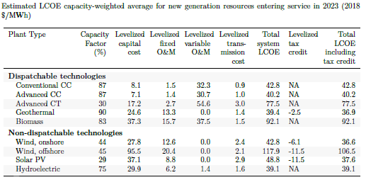

Despite the high price of OSW in the U.S., many states are taking steps towards incentivizing and implementing the technology. Recent state advancements in supporting OSW projects and supply chain include the following [30]:

* California: 2019 memorandum of understanding between Castle Wind and Monterey Bay Community Power outlining intent to enter a long-term power purchase agreement for 1 GW of OSW [31]
* Connecticut: 2018 Connecticut Department of Energy and Environmental Protection generation-based RFP for renewable energy, including OSW; $15 million investment to revitalize a shipping pier; 2019 law outlining target to develop up to 2,000 MW of OSW by 2030 [32]
* Maine: 2019 Maine Offshore Wind Initiative and floating offshore turbine demonstration project announced by the Governor
* Maryland: 2013 Offshore Wind Energy Act developed Offshore Wind Renewable Energy Credits (ORECs), which can be applied to the state’s RPS; 2017 first OSW solicitation of 389 MW; 2019 1,200 MW OSW mandate by 2030 [33]
* Massachusetts: 2016 law requiring procurement of 1,600 MW of OSW by 2027, updated to 3,200 MW in 2019 [34]; 2018 selected Vineyard Wind project as first OSW project for 800 MW; 2018 BOEM held auctions for three lease areas with 32 rounds of bidding; 2019 second solicitation for 400-800 MW projects
* New Jersey: 2018 law outlining target to develop 3,500 MW of OSW by 2030, the first 1,1000 MW of which have been won by Ørsted [35]
* New York: 2017 Governor commitment to develop up to 2.4 GW of OSW by 2030; 2018 solicitation of at least 800 MW in two RFPs; $15 million investment to train for OSW jobs and develop port infrastructure; 2019 OSW mandate updated to 9 GW by 2035 and procurement solidified July 2019 for 1,700 MW between two projects [36]
* Rhode Island: 2018 competitive procurement for 400 MW of OSW, in collaboration with Massachusetts
* Virginia: 2018 Governor released Virginia Energy Plan, calling for 2,000 MW OSW by 2028; 12 MW Coastal Virginia Offshore Wind Project, first fully-permitted OSW project in Federal waters with an order from Siemens Gamesa for two 6-MW turbines and BOEM permits; 2019 Dominion Energy proposes largest OSW project in U.S. of 2.6 GW from 220 turbines by 2026 [37]

The large market in the U.S. is at a tipping point, with a project pipeline of 25,600 MW of OSW energy as of July 2019. Specific projects account for 4,864 MW of that capacity and the remaining 20,736 MW are comprised of undeveloped lease area. Of the project-based capacity, 4,831 MW is expected to be built and online by 2024.

Renewable energy has grown significantly in the U.S. as states have adopted RPS and emissions reductions goals, especially as costs have declined. It is uncertain, however, how OSW will play into the current grid mix. A multitude of factors elicit greater amounts of specific technologies in different regions depending on natural resource availability, demand growth, age of existing generation assets, incentive policies, and many more factors. Little research exists for the impact of OSW to the grid mix in the U.S., but many other countries are taking initiative to assess how OSW fits in. These efforts have focused primarily on European countries and China, as they were the first and most prolific adopters of renewable technologies. For example, many researchers have begun assessing the opportunities in China for OSW to offset carbon-intensive generation [38-40] as well as more wholistic investigation into OSW planning for emissions reductions goals [41, 42]. Similarly, research has sought to quantify the ability of renewable technologies to contribute to emissions goals [43-45], and wind specifically [46]. This research has shown a direct correlation between adoption of renewable technologies and emissions reductions, accounting for demand and population growth.

Electric sector emissions reductions contribute to benefits for the environment, human health, and climate, often referred to as “co-benefits”. Analyses have been done to quantify the positive human health co-benefits from sectoral emissions reductions [47, 48] and more general climate mitigation efforts [49, 50]. Additional research has quantified the environmental and climate co-benefits of low carbon technologies [51-53].

U.S.-specific research has estimated the environmental co-benefits of low-carbon pathways [54, 55], and has begun to investigate wind specifically [56, 57]. In 2017, BOEM issued a report evaluating electricity system, environmental, and socioeconomic benefits offered by OSW [58], modeling a novel approach to quantifying more than costs and impacts when assessing new technologies. The U.S., while adopting very little OSW, has installed nearly 98 GW of terrestrial wind power [59], allowing for real-time analysis of emissions mitigation potential and the resulting impacts on and benefits for environmental, human health, and climate [60, 61]. As interest in OSW has grown, so has investigation into the co-benefits that the technology can bring at the local level. Two studies on the state of Michigan showed that both terrestrial and offshore wind could bring environmental, air quality, and quality of life benefits to the counties that would host or border the turbines [62, 63]. They found that emissions reduction benefits varied across pollutant and locality, but that overall reductions were likely across all pollutants. A similar study focused on Mid-Atlantic states found direct human health and climate benefits from OSW specifically, citing the greatest differences in benefits coming from locality and facility generation capacity [64]. It must be noted that OSW does not produce emissions from generation, however materials production, construction, and operation of OSW have their own emissions footprints, which are quantified in life-cycle analyses [65-67], and there are emissions consequences when variable renewable resources must be paired with dispatchable, fossil-fuel generators to meet demand when renewable generation drops [68]. These contextual emissions have not yet been worked into a larger systems-approach to emissions mitigation, nor are they accounted for in this study.

These studies demonstrate the direct effects and benefits of wind technologies to their surroundings, but do not quantify the national impact that OSW would have on emissions. The U.S. Bureau of Ocean Energy Management (BOEM), the agency responsible for OSW leasing areas, announced in June of 2019 that it would publish a “request for competitive interest” to build a transmission line for OSW off the coasts of New York and New Jersey [69]. A planned transmission system for OSW would promote long-term success and interest in the OSW market, and likely increase the chances of the U.S. market accelerating OSW development. The growing state and federal interests in OSW require a more robust analysis of this technology within the broader system.

## 3. Materials and Methods

3.1 Model and Database

The TIMES model and EPAUS9rT energy system database, together, provide a comprehensive look at the U.S. energy system. The EPA’s Office of Research and Development has worked to develop the TIMES-EPAUS9rT modeling system to investigate energy system futures that optimize for lowest cost over all economic sectors [70]. This allows the use of one model for all sectors instead of a piecemeal approach, showing the interplay and tradeoffs between sectors as scenarios change.

The TIMES model is developed by the Energy Technology Systems Analysis Program (ETSAP), one of the longest running programs at the International Energy Agency (IEA) [71]. The TIMES model is a long-term energy system optimization model (ESOM) and is used for investment and operation decision support. It uses a bottom up approach with multi-year temporal resolution and user defined time slices to model for long time-horizons [72]. The TIMES model includes a wide range of commodity-related variables such as total production, total consumption, and process flows. Additionally, TIMES can allocate costs across investment timelines.

The TIMES model is a Linear Program formulated using the GAMS modeling language that maximizes system surplus and minimizing system costs. This formulation is called the *total system cost* [71].

Equation : TIMES Objective Function

$$NPV= \sum_{r=1}^{R}{\sum_{y∈YEARS}{{(1+d_{r,y})}^{REFYR-y}×ANNCOST(r,y)}}$$

Where:

* *NPV* is the net present value of total cost for all regions;
* *ANNCOST(r,y)* is the total annual cost in region *r* and year *y*;
* *dr,y* is the overall discount rate;
* *REFYR* is discounting reference year;
* *YEARS* is the number of years for which the results will be modeled; and
* *R* is the group of regions in the study.

The TIMES objective is to minimize the total *cost* of the system, augmented by the *cost* of lost demand. All cost elements are discounted to a user-selected year [71]. The current EPAUS9rT database and its TIMES implementation uses 2010 as the base year and is calibrated to the present year.

The EPAUS9rT database represents the U.S. by census regions, as can be seen in Figure 4. OSW’s representation in this model is at this region-level and accounts for the geographic and economic variability of the resource. The OSW resources within the model span every census region except for Region 8 (Mountain West), due to no offshore resources being directly accessible from this territory. For each of the remaining 8 regions, the model represents technologies for OSW spanning the following characteristics: water depth (shallow and deep), wind class, and cost class. Capacity factors vary by time of day, season, technology, and region. For each OSW installation, a lifetime of 30 years was assumed. The model sets a capacity bound for type of OSW in each region based on technical feasibility. What is not considered in the model is the practical timeframe in which all the available OSW development area will become available. BOEM, an agency within the U.S. Department of the Interior, must assess outer continental shelf areas for leasing potential before they may be developed. Additionally, the model does not account for political feasibility of building OSW, which has proven to be a contentious technology in the U.S.

3.2 Scenarios

All scenarios constructed and evaluated in the TIMES model run from 2010 to 2050.

CO2 mitigation scenarios were constructed to linearly reduce emissions from 2010 to 2050 by percentage of 2010 electric sector CO2 emissions and were implemented as an electric sector CO2 upper bound (CO2 cap) (Figure 1a). The 2010 emissions were calculated endogenously, using the TIMES model and EPAUS9rT database. The baseline emissions reduction scenario assumed no carbon mitigation requirement and reaches approximately a 25% CO2 reduction by 2050. This case will be referred to as the business as usual (BAU) emissions case. Each subsequent scenario increased the required carbon mitigation percentage by 10%, until an 80% carbon reduction is achieved by 2050.

Cost curves for OSW were constructed to linearly decline from 2015 to 2035 by a percentage of current costs (Figure 1b). Capital expenditure (CAPEX) was back-calculated from LCOEs presented in the Energy Information Administration’s (EIA) Annual Energy Outlook 2018 (AEO). The baseline cost reduction scenario assumes a 20% cost decrease, as is expected through normal technological advancement and “learning”. Five additional cost curves were constructed at 10% intervals, spanning from a 30% to an 80% reduction in the cost of OSW by 2035.

The reference case for this study is represented with the BAU CO2 cap and 20% OSW cost reduction scenarios.

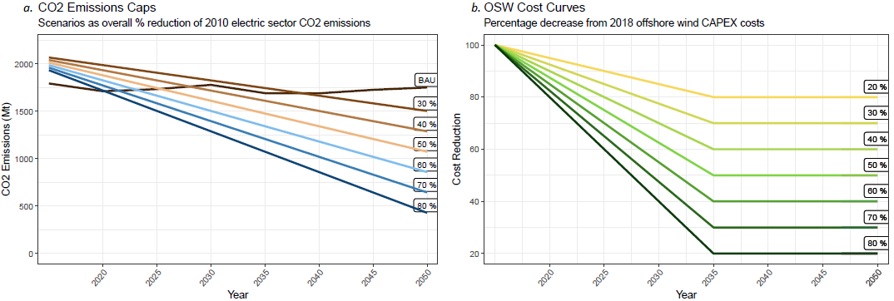

Figure . a. CO2 Cap and b. OSW Cost Curve Scenario Construction

## Results and Discussion

A total of 49 scenarios were created, representing the combination of all cost curves and CO2 caps. The model results show that OSW was not built out in all cases, as represented in Figure 2. Until the cost of OSW is reduced by 40%, it is not economically viable, and at 40% cost reductions it is only built in the most stringent carbon mitigation scenario. At a 50% cost reduction 21 GW of OSW is built by 2050 in the 80% carbon mitigation scenario, though only 11 GW is built in the 70% carbon mitigation scenario. At a 60% cost reduction and above, OSW is built in all carbon mitigation scenarios, with the largest capacity coming at the highest cost reduction across all carbon mitigation scenarios.

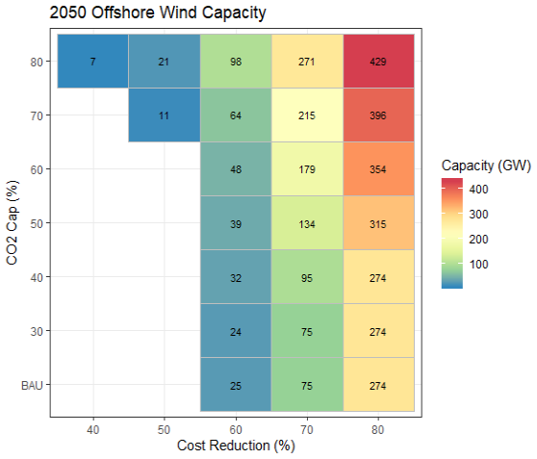

Figure . Total OSW Capacity in 2050

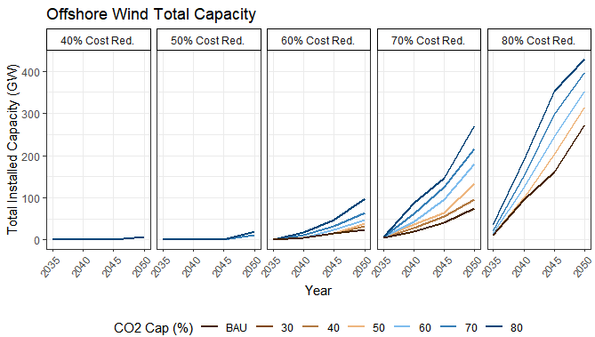

Figure . Total OSW Capacity by Scenario

OSW’s sensitivity to carbon mitigation stringency is well defined across all technology costs. More stringent carbon caps elicit the buildout of OSW sooner, and at larger capacities (Figure 3). Additionally, the less expensive OSW becomes, the more capacity is built out each time period, regardless of carbon mitigation stringency.

Overall buildout of OSW varied across regions, with no capacity added in Regions 4, 6, and 8 (Figure 4). The EPAUS9rT database does not have OSW availability for Region 8 because there is no coastline, and Regions 4 and 6 have very little resource availability. Of the regions where OSW was built, Region 5 elicited the largest buildout and Region 7 the smallest, though the differences also varied between scenarios.

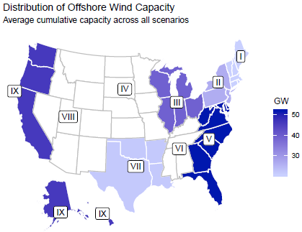

Figure . Average OSW capacity per region across scenarios

OSW, as a new technology, can be built to replace existing generation or to add capacity as electricity demand grows. All scenarios show electricity demand growth over time, but the degree of the growth varies between scenarios. CO2 caps limit the increase in total electricity generated as they become tighter, showing that the carbon constraint affects demand and electricity end uses (Figure 5). As OSW gets less expensive, however, total electricity production grows, compensating for and even increasing the total output over the reference case. When OSW is the least expensive and there is no carbon cap, total electricity production is 9% greater than when it is most expensive with a stringent carbon cap. Across the tightest carbon cap scenarios, OSW is still able to elicit a 5% increase in total electricity production when it is least expensive.

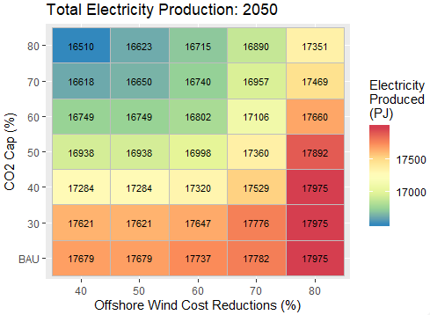

Figure . Total electric sector electricity production in 2050

In most cases, the deployment of OSW displaces coal, natural gas, terrestrial wind, and solar PV (Figure 7), though the technologies displaced vary between scenarios. Figure 7 shows the differences in electricity production between the indicated cases and the reference case (Figure 6), with net increases above the dotted red line and net decreases below the red line. When OSW cost reductions are only 50%, little OSW is built. In order to meet the increasingly stringent CO2 caps, solar, terrestrial wind, and coal carbon capture and storage (Coal CCS) are built and displace the existing coal and new natural gas built in the reference case. At a 60% cost reduction, more OSW is built, displacing what would have otherwise been new solar, terrestrial wind, or coal CCS. As costs decrease to 70% and 80%, almost all added capacity is OSW, as it becomes less expensive than other carbon-free electric generation resources.

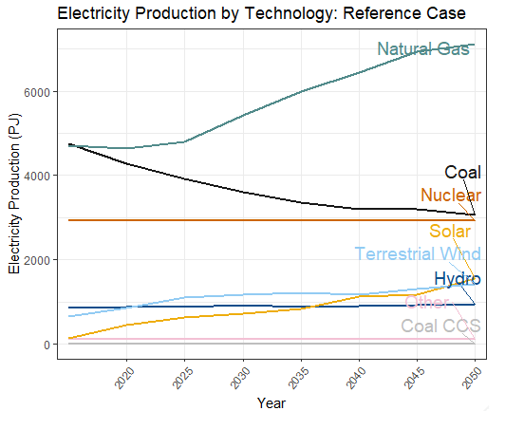

Figure . Reference case electricity production by technology

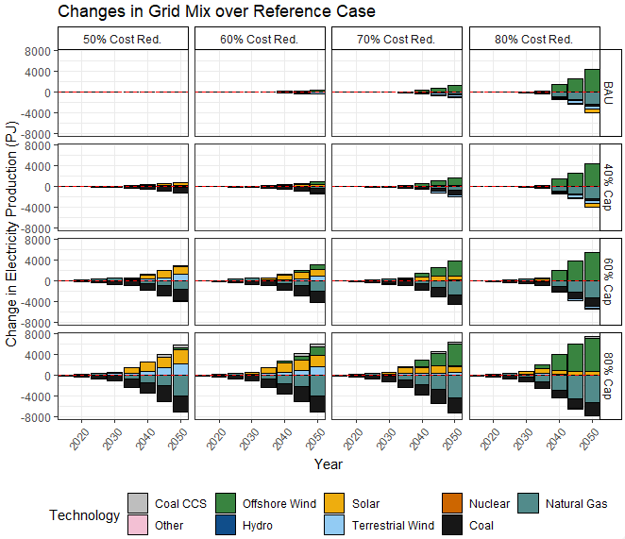

Figure . Capacity additions and retirements in relation to the reference case

In scenarios where OSW costs are low and new capacity is high, natural gas is the most displaced technology, whereas when OSW cost are high and new capacity is low, more coal is retired. Natural gas makes up a large market share of the 2050 grid in all scenarios regardless of OSW buildout (Table 2), but natural gas capacity additions are dramatically reduced as the cost of OSW falls. Coal sees a similar displacement when OSW is built out in low quantities, though as OSW costs decline and capacity increases, coal retirements slow and more existing coal remains over time. This shows the tradeoff between building new carbon-free but non-dispatchable capacity and needing to meet demand at all times.

Over all scenarios, the largest market share that OSW achieves is 38% in the lowest cost and highest carbon mitigation stringency scenario. In all lowest cost reduction scenarios, OSW gains significant market share, but as costs increase that market share is more sensitive to the stringency of the CO2 cap.

Table . Percent market share by technology in 2050 (Technology PJ/Total electric sector PJ)

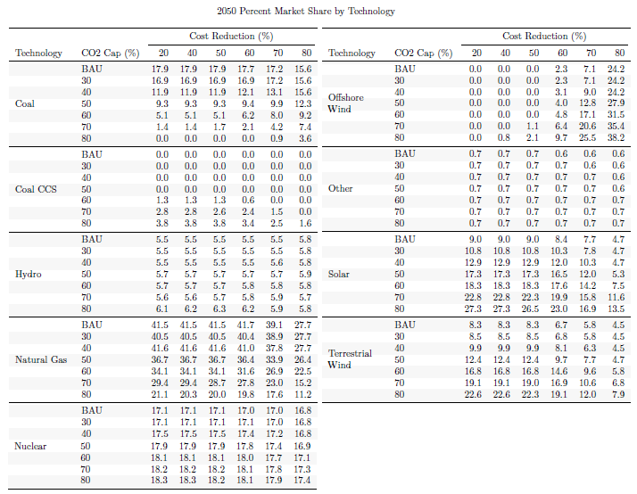

Additionally, as OSW becomes less expensive than solar and terrestrial wind, these renewable technologies retain marginally less market share than they would have in the reference case. However, the total contribution of renewables increases as OSW costs decrease, across all CO2 cap scenarios since OSW capacity additions equal or surpass those of other renewable sources.

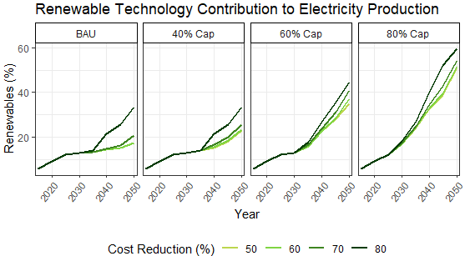

Figure . Percent of electric sector production from renewable technologies. Renewable technologies include solar, terrestrial wind, and OSW.

Electric sector CO2 emissions constraints similarly constrain the other emissions investigated because they are cogenerated during fossil fuel combustion. The addition of OSW to the grid mix and the changes that it elicits vary the degree to which these emissions are reduced. As shown in Figure 9, all pollutants saw a significant reduction in emissions, with the greatest reduction in SO2. The dramatic decrease in SO2 emissions stems from the model’s representation of existing SO2 policies severly limit electric sector emissions and have realized benefits after the 2010 reference year. There is a clear trend showing greater reductions in all emissions as carbon mitigation stringency increases. For CO2, SO2, NOx, and CH4, tighter carbon constraints lead to emissions reductions surpassing the reference case beginning no later than 2030. This does not hold for PM2.5, however, as OSW costs cause more variation in the pace at which this emission is reduced. Due to the tradeoff between OSW and the slowing of coal retirements, PM2.5 emission reductions do not outpace the reference case when OSW is less expensive and gains larger market shares.

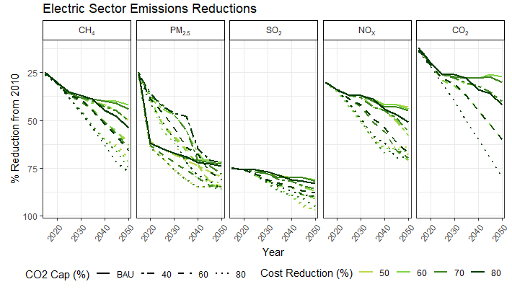

Figure . Electric sector emissions reductions

Another less obvious tradeoff occurs in the industrial sector. The industrial sector both consumes electricity provided by the grid and produces its own using combined heat and power (CHP). The CO2 cap scenarios only apply to the electric sector and do not include emissions from industrial CHP. As the CO2 cap tightens, there is a small shift from industrial grid electricity use to CHP electricity production (Figure 10). While there is an increase in emissions from increased CHP, the increases are minimal in comparison to the much larger reductions seen in the electric sector as a whole.

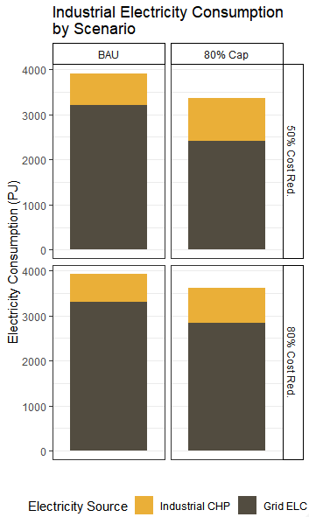

Figure . Industrial sector CHP and Grid electricity use

Due to the fact that OSW displaces emissions-neutral and fossil fuel technologies differently between scenarios, it is difficult to qualitatively disentangle the effects of OSW costs and carbon mitigation stringency on total emissions reductions. In order to tease out this complexity, we looked at the confounding factors. Carbon mitigation stringency elicited a higher percentage of renewables independent of OSW cost, though OSW cost did contribute to higher percentages of renewable generation in all scenarios (Figure 8). Additionally, carbon mitigation stringency had a marked impact on total electricity production, reducing overall production in scenarios with high mitigation stringency (Figure 5).

Two sets of regression analyses were used to identify the strength of the study parameters’ effects on the electric sector and its emissions. All regression analyses use 2050 values for the independent variables and are applied across all model runs that had OSW buildout.

The first set of regressions looks at the impact of the scenario parameters, CO2 caps and OSW costs, on total OSW capacity, percentage of renewable generation, and total electricity production. Figure 11 shows the parameter coefficients, or strength of the parameter effects, for all three independent variables. All coefficients are statistically significant for both CO2 caps and OSW cost reduction. Cost reduction has a substantially greater positive influence on OSW capacity than carbon mitigation stringency, though both contribute to higher OSW capacity. Both parameters also have a positive effect on the market share of renewables, with CO2 caps playing a greater role increasing that share. Total electricity production is reduced by the CO2 caps but increased by OSW cost reductions. The increase achieved by OSW deployment outweighs the reductions caused by the caps, leading to a net increase in production as OSW costs decrease.

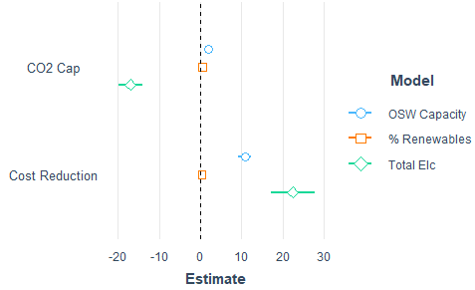

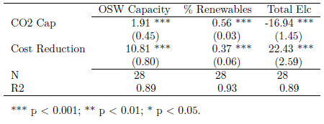

Figure . Electric sector regression analyses

The second set of regressions looks at the impact of two parameters, CO2 caps and OSW capacity, on electric sector CO2, SO2, NOx, PM2,5, and CH4 emissions (Figure 12). OSW capacity is used instead of OSW cost reductions in order to more closely align the direct effect of OSW on electric sector emissions. CO2 caps show statistically significant reduction effects on all five emissions. OSW capacity effects were only statistically significant for CO2, SO2, and PM2.5. OSW contributes to CO2 reductions, though to a much smaller degree than the CO2 caps, which is to be expected. SO2 increases as OSW capacity increases, though again, to a much smaller degree than the CO2 caps reduce SO2, leading to a net decrease in SO2 emissions for all OSW cost scenarios. PM2.5 is reduced as OSW capacity increases, though the reduction effect of the CO2 caps outweighs the effect of OSW capacity.

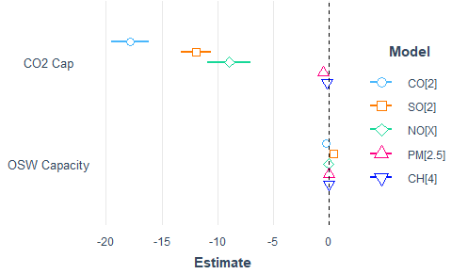

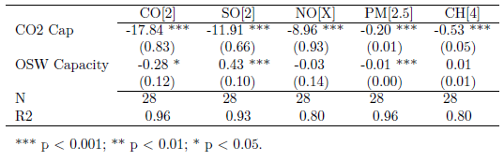

Figure . Emissions regression analyses

These regression results include all model runs that had OSW buildout, providing meaningful but broad insight into the emissions reduction potential of the two study parameters. In order to more acutely assess the potential for OSW to reduce emissions, we conducted a third set of regressions, one for each set of runs at a given CO2 cap. These regressions showed a much stronger potential for OSW to contribute to emissions reductions, with negative and statistically significant coefficients for OSW capacity for all five emissions in the BAU cases. All coefficients were negative, but not all were statistically significant with 30% CO2 cap. For all other carbon mitigation scenarios, OSW affected emissions more consistent with the regressions shown in Figure 12.

## Conclusions

In this research, we used a TIMES modeling framework to assess the potential for OSW capacity expansion and its sensitivity to CO2 mitigation stringency and OSW cost reductions. We also measured the impact that OSW capacity would have on the generation resource makeup of the grid and the resulting emissions implications.

This paper found that costs for OSW will need to decrease by at least 40% to compete on the market with other technologies, both renewable and fossil fuel. When costs are reduced by 50%, substantially more OSW is built, as with 60%, 70% and 80%. OSW reaches its highest modeled market share at 38% with cost reductions and CO2 mitigation both at 80%. At each price point, more OSW capacity is built as CO2 mitigation stringency increases. Both study parameters have a positive effect on capacity buildout as they increase, with costs having the greatest positive impact.

The pipeline for OSW development in the U.S. is growing and the research about the technical feasibility is robust, but we are missing the future-looking research to assess how this technology will fit in, what will be displaced and when, and how it might affect our air quality and emissions goals. This research characterizes OSW within this context to show how the grid’s generation mix will change. As carbon mitigation stringency increases, natural gas and coal are displaced at higher rates. When OSW is too expensive to compete in the market, solar and terrestrial wind capacity is added to meet demand and lower emissions to meet the cap. As OSW costs decrease, it is better able to compete with other renewable technologies, as well as new natural gas and existing coal. With lower OSW costs, there is a greater displacement of new natural gas and slower growth of solar and terrestrial wind. Despite slower solar and terrestrial wind growth, OSW capacity additions lead to an overall increase in renewable contributions ot the grid.

CO2 caps elicited statistically significant reductions in CO2, SO2, NOx, PM2,5, and CH4 emissions. OSW capacity elicited statistically significant reductions in CO2 and PM2.5, though these reductions are smaller than those from the CO2 caps. SO2 is statistically significantly increased by OSW capacity, though there is still a net reduction due to the CO2 caps reduction effects. Higher capacities of OSW, especially in the 80% cost reduction scenarios, require a greater capacity of dispatchable resources, slowing coal retirements by keeping them running longer than they would otherwise. Thus, this tradeoff impacts the potential for OSW to lower SO2 and PM2,5 emissions. OSW capacity elicits more pronounced and consistent reductions in all emissions at the least stringent CO2 caps as there is no forced tradeoff between OSW and coal.

Some of the emissions reductions in the electric sector are offset by gains due to end-use sector electricity production. Under tight CO2 caps, the industrial sector consumes less electricity from the grid, where the CO2 cap is applied, and increases its own electricity production with CHP. Despite the increase in industrial emissions, there is still a significant overall reduction across all emissions.

The benefits of systems approach, as is the case with the TIMES model and EPAUS9rT database, can be seen in the identification of these tradeoffs. OSW is a new technology to the U.S. and its potential energy system effects cannot be fully analyzed unless the system can be seen as a whole. With new emerging technologies, such as electric vehicles and hydrogen fuel, the electric sector and electric generation are less isolated than they have been in the past. In many ways, electricity operates more as a traditional fuel as the economy is electrified and generation resources diversify. With this research we are able to characterize the role that OSW plays in this system, as well as the potential it holds to reduce emissions.

Further research might apply this methodology to a database that includes the OSW mandate policies of U.S. states and incorporates technology learning curves based on the current pipeline, assuming it comes to fruition. The technology landscape and cost reduction pathways are not yet developed, and state policies are likely to shape these as OSW begins to be built. Changes to emerging technology costs, and thus electricity costs, are likely to affect end-use electrification and cross-sector tradeoffs. Focusing research in this area could assess system-wide emissions outputs and sensitivities to the model parameters. Additionally, incorporating OSW life-cycle analyses and emissions accouting could give a broader picture of the total emissions implications of adding OSW capacity.

The emissions reduction potential of OSW was analyzed at a national level in this study, but the TIMES-EPAUS9rT modeling system can provide results at the census region level. CO2 caps could instead be applied at the regional level to better mimic state RPS and emissions goals. Extending the study to quantify emissions reduction benefits for environmental and human health would provide additional assessment of OSW, or another emerging technology, at a national or regional level.

## Notes on Modeling

The TIMES model [71] was implemented using the VEDA FrontEnd and BackEnd software suite and the EPAUS9rT database. OSW representation was developed for the database using the National Renewable Energy Laboratory’s Regional Energy Deployment System (ReEDS) model and database. No additional transmission expansion or offshore transmission system was modeled. This version of the EPAUS9rT database can be made available upon request by contacting author Carol Lenox (lenox.carol@epa.gov).

## Disclaimer

The views expressed in this article are those of the authors and do not necessarily represent the views or policies of the U.S. Environmental Protection Agency. The authors declare no special interests.

## Acknowledgments

The authors would like to thank Dr. Jacky Rosati and Ms. Cara Marcy for their valuable input during the administrative review of this manuscript.

## Data Availability

The EPAUS9rT database and its corresponding documentation can be found at

<https://cfpub.epa.gov/si/si_public_record_report.cfm?Lab=NRMRL&dirEntryId=346478>.

## References

1. NOAA, *American Community Survey Five-Year Estimates [NOAA Office for Coastal Management, U.S. Census Bureau]*, NOAA, Editor. 2014.

2. NOAA, *National Coastal Population Report: Population Trends from 1970 to 2020*, in *NOAA's State of the Coast*. 2013.

3. Musial, W., et al., *2016 Offshore Wind Energy Resource Assessment for the United States.* National Renewable Energy Laboratory, 2016(NREL/TP-5000-66599).

4. Green, R. and N. Vasilakos, *The economics of offshore wind.* Energy Policy, 2011. **39**: p. 496-502.

5. Myhr, A., et al., *Levelised cost of energy for offshore floating wind turbines in a life cycle perspective.* Renewable Energy, 2014. **66**: p. 714-728.

6. Stehly, T., et al., *2017 Cost of Wind Energy Review*. 2017, National Renewable Energy Laboratory.

7. NCCETC, *Renewable and Clean Energy Standards: Database of State Incentives for Renewables and Efficiency*, N.C.C.E.T. Center, Editor. 2019.

8. C2ES, *U.S. State Greenhouse Gas Emissions Targets*, C.f.C.a.E. Solutions, Editor. 2019.

9. U.S. EIA, *US electricity generation by energy source*, U.S.E.I. Administration, Editor. 2018.

10. U.S. EIA, *U.S. primary energy consumption by energy source, 2018*, U.S.E.I. Administration, Editor. 2018.

11. U.S. EIA, *Annual Energy Outlook 2019 - with projections to 2050*, U.S.E.I. Administration, Editor. 2019.

12. U.S. EPA, *National Emissions Inventory Report*, U.S. EPA, Editor. 2014.

13. U.S. EPA, *Inventory of U.S. Greenhouse Gas Emissions and Sinks: 1990-2017 Inventory Report*, U.S. EPA, Editor. 2017.

14. Loughlin, D.H., et al., *Methodology for examining potential technology breakthroughs for mitigating CO2 and application to centralized solar phovoltaics.* Clean Technologies and Environmental Policy, 2012. **15**(1): p. 9-20.

15. GWEC, *Global Wind Energy Council: Global Wind Report 2018*. 2019, Global Wind Energy Council.

16. Beiter, P., et al., *An Assessment of the Economic Potential of Offshore Wind in the United States from 2015 to 2030.* National Renewable Energy Laboratory, 2017(NREL/TP-6A20-67675).

17. Bosch, J., I. Staffel, and A.D. Hawkes, *Temporally explicity and spatially resolved global offshore wind energy potentials.* Energy, 2018. **163**: p. 766-781.

18. Staid, A. and S.D. Guikema, *Risk Analysis for U.S. Offshore Wind Farms: The Need for an Integrated Approach.* Risk Analysius, 2015. **35**(4): p. 587-593.

19. Dupont, E., R. Koppelaar, and H. Jeanmart, *Global available wind energy with physical and energy return on investment constraints.* Applied Energy, 2018. **209**: p. 322-338.

20. Huang, F., H. Wang, and B. Wen, *A grid-side reactive power control strategy for highly offshore wind power penetrated systems.* Renewable and Sustainable Energy Reviews, 2018. **10**.

21. Moller, B., *Continuous spatial modelling to analyse planning and economic consequences of offshore wind energy.* Energy Policy, 2011. **39**: p. 511-517.

22. Dedecca, J.G., R.A. Hakvoort, and P.M. Herder, *Transmission expansion simulation for the European Northern Seas offshore grid.* Energy, 2017. **125**: p. 805-824.

23. Houghton, T., K.R.W. Bell, and M. Doquet, *Offshore transmission for wind: Comparing the economic benefits of different offshore network configurations.* Renewable Energy, 2016. **94**: p. 268-279.

24. Jin, R., et al., *Cable routing optimization for offshore wind power plants via wind scenarios considering power loss cost model.* Applied Energy, 2019. **254**: p. 113719.

25. Daniel, J.P., et al., *National Offshore Wind Energy Grid Interconnection Summary.* U.S. Department of Energy, 2014.

26. St. John, J., *Offshore Wind Reaches Cost-Competitiveness withouth Subsidies*, in *Greentech Media*. 2017.

27. General Electric. *Haliade-X Offshore Wind Turbine*. 2019; Available from: <https://www.ge.com/renewableenergy/wind-energy/offshore-wind/haliade-x-offshore-turbine>.

28. Lazard, *Lazard's Levelized Cost fo Energy Analysis - Version 12.0*. 2018.

29. Mora, E.B., et al., *The effects of mean wind speed uncertainty on project finance debt sizing for offshore wind farms.* Applied Energy, 2019. **252**: p. 113419.

30. AWEA, *U.S. Offshore Wind Industry Status Update*, A.W.E. Association, Editor. 2019.

31. Castle Wind, *Castle Wind and Monterey Bay Community Power Sign Agreement in Anticipation of Offshore Wind Project Off the Coast of Morro Bay*. 2019, Castle Wind.

32. *An Act Concerning the Procurement of Energy Derived from Offshore Wind*. 2019.

33. *An Act Concerning Clean Energy Jobs*. 2019.

34. *An Act to Advance Clean Energy*. 2018.

35. NJ Board of Public Utilities, *New Jersey Board of Public Utilities Awards Historic 1,100 MW Offshore Wind Soliciation to Orstead's Ocean Wind Project*, S.o.N.J.B.o.P. Utilities, Editor. 2019.

36. *Climate Leadership and Community Protection Act*. 2019.

37. Dominion Energy, *Dominion Energy Announces Largest Offshore Wind Project in US*. 2019: <https://www.virginiamercury.com/2019/09/24/four-things-to-know-about-dominions-massive-wind-farm-proposal/>.

38. Liu, J., et al., *Mitigation pathways of air pollution from residential emissions in the Beijing-Tianjin-Hebei region in China.* Environment International, 2019. **125**: p. 236-244.

39. Guan, D., et al., *Structural decline in China’s CO2 emissions through transitions in industry and energy systems.* Nature Geoscience, 2018. **11**(8): p. 551-555.

40. Lu, X., et al., *Opportunity for Offshore Wind to Reduce Future Demand for Coal-Fired Power Plants in China with Consequent Savings in Emissions of CO2.* Environmental Science and Technology, 2014. **48**: p. 14764-14771.

41. Zeng, J., et al., *The impacts of China's provincial energy policies on major air pollutants: A spatial econometric analysis.* Energy Policy, 2019. **132**: p. 392-403.

42. Lu, X., et al., *Optimal integration of offshore wind power for a steadier, environmentally friendlier, supply of electricity in China.* Energy Policy, 2013. **62**: p. 131-138.

43. Cali, U., et al., *Techno-economic analysis of high potential offshore wind farm locations in Turkey.* Energy Strategy Reviews, 2018.

44. Clancy, J.M., et al., *Fossil fuel and CO2 emissions savings on a high renewable electricity system - A single year case study for Ireland.* Energy Policy, 2015. **83**: p. 151-164.

45. Lu, X., et al., *Challenges faced by China compared with the US in developing wind power.* Nature Energy, 2016. **1**(6): p. 16061.

46. Holttinen, H. and S. Tuhkanen, *The effect of wind power of CO2 abatement in the Nordic Countries.* Energy Policy, 2004. **32**: p. 1639-1652.

47. Zhang, S., et al., *Modeling energy efficiency to improve air quality and health effects of China's cement industry.* Applied Energy, 2016.

48. Peng, W., et al., *Substantial air quality and climate co-benefits achievable now with sectoral mitigation strategies in China.* Science of the Total Environment, 2017. **598**: p. 1076-1084.

49. Xie, Y., et al., *Co-benefits of climate mitigation on air quality and human health in Asian countries.* Environment International, 2018. **119**: p. 309-318.

50. Peng, W., et al., *Potential co-benefits of electrification for air quality, health, and CO2 mitigation in 2030 China.* Applied Energy, 2018. **218**: p. 511-519.

51. Yang, J., D. Song, and F. Wu, *Regional variations of environmental co-benefits of wind power generation in China.* Applied Energy, 2017. **206**: p. 1267-1281.

52. Yang, J., *Environmental and Climate Change Co-Benefits Analysis of Wind Power Generation in China.* Energy Procedia, 2016. **88**: p. 76-81.

53. Yuan, J., Z. Yuan, and X. Ou, *Modeling of environmental benefit evaluation of energy transition to multi-energy complementary system.* Energy Procedia, 2019. **158**: p. 4882-4888.

54. Ou, Y., et al., *Estimating environmental co-benefits of U.S. low-carbon pathways using an integrated assessment model with state-level resolution.* Applied Energy, 2018. **216**: p. 482-493.

55. Dimanchev, E.G., et al., *Health co-benefits of sub-national renewable energy policy in the US.* Environmental Research Letters, 2019. **14**.

56. Novan, K., *Valuing the Wind: Renewable Energy Policies and Air Pollution Avoided.* American Economic Journal: Economic Policy, 2015. **7**(3): p. 291-326.

57. Millstein, D., et al., *The climate and air-quality benefits of wind and solar power in the United States.* Nature Energy, 2017. **2**: p. 17134.

58. U.S. Department of the Interior and Bureau of Ocean Energy Management, *Evaluating Benefits of Offshore Wind Energy Projects in NEPA*. Headquarters, Sterling, VA.

59. AWEA, *U.S. Wind Industry Annual Market Report, Year Ending 2018*. 2018.

60. Greene, J.S. and M. Morrissey, *Estimated Pollution Reduction from Wind Farms in Oklahoma and Associated Economic and Human Health Benefits.* Journal of Renewable Energy, 2012. **2013**.

61. Lu, X., M.B. McElroy, and N.A. Sluzas, *Costs for Integrating Wind into the Future ERCOT System with Related Costs for Savings in CO2 Emissions.* Environmental Science and Technology, 2011. **45**: p. 3160-3166.

62. Nordman, E., et al., *An Integrated Assessment for Wind Energy in Lake Michigan Coastal Counties.* Integrated Environmental Assessment and Management, 2014. **11**(2): p. 287-297.

63. Chiang, A.C., et al., *Emissions reduction benefits of siting an offshore wind farm: A temporal and spatial analysis of Lake Michigan.* Ecological Economics, 2016. **130**: p. 263-276.

64. Buonocore, J.J., et al., *Health and climate benefits of offshore wind facilities in the Mid-Atlantic United States.* Environmental Research Letters, 2016. **11**(7).

65. Reimers, B., B. Ozdirik, and M. Kaltschmitt, *Greenhouse gas emissions from electricity generated by offshore wind farms.* Renewable Energy, 2014. **72**: p. 428-438.

66. Huque, J.C.V.S.V.B.H.D.R.R.K.Z., *Life Cycle Environmental Impact of Onshore and Offshore Wind Farms in Texas.* Sustainability, 2018. **10**: p. 2022-2039.

67. Kaldellis, J.K. and D. Apostolou, *Life cycle energy and carbon footprint of offshore wind energy. Compariosn with onshore counterpart.* Renewable Energy, 2017. **108**: p. 72-84.

68. Apt, W.K.J., *Air Emissions Due to Wind and Solar Power.* Environmental Science and Technology, 2008. **43**: p. 253-258.

69. Bureau of Ocean Energy Management, *BOEM Announces Next Steps for Proposed New York - New Jersey Wind Energy Transmission Line: Includes Opportunity for Expressions of Competitive Interest and Public Comments*. 2019.

70. Lenox, C., *EPAUS9rT database for use with the TIMES modeling platform*. 2019: U.S. EPA, Washington, DC.

71. Loulou, R., et al., *Documentation for the TIMES model.* Tech. Rep. Energy Technology Systems Analysis Programme (ETSAP), 2005.

72. Ringkjob, H.-K., P.M. Haugan, and I.M. Solbrekke, *A review of modelling tools for energy and electricity systems with large shares of variable renewables.* Renewable and Sustainable Energy Reviews, 2018. **96**: p. 440-459.